1. Check out following code base from SVN under same root folder

<https://184.69.193.254:9880/eServiceExpress/trunk>

<https://metashare.ca:9880/eServiceMDM/trunk>

<https://184.69.193.254:9880/eServiceOnline/branches/v20181228ScheduleBoard>

<https://184.69.193.254:9880/SanjelClientSolutionTool/branches/v20181018>

<https://184.69.193.254:9880/SanjelCommonLibrary/branches/v20180929>

<https://184.69.193.254:9880/SanjelEService/trunk>

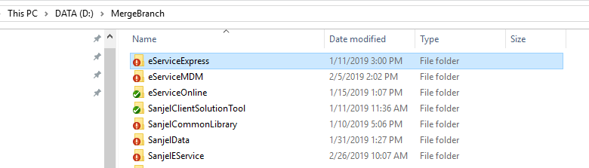

1. Compile CommonLibrary and eService solutions
2. Make following change according to release environment
   1. Update release number

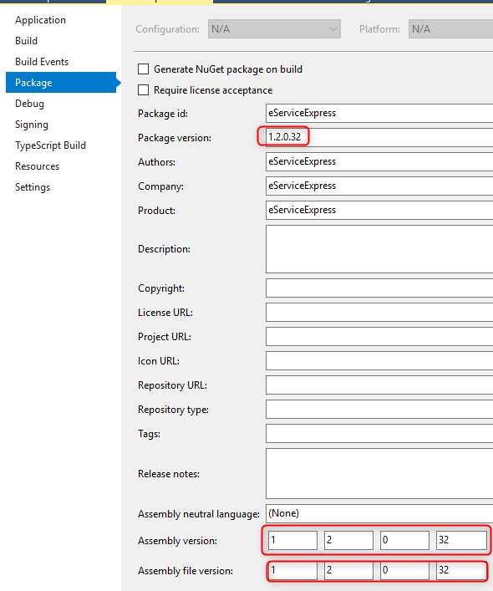

* 1. Update Application Context in app.config file

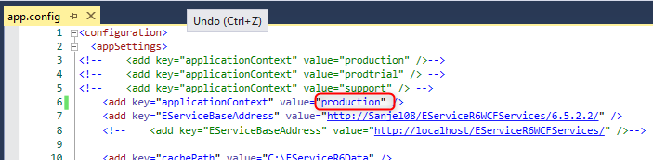

* 1. Compile the whole eService Express solution
  2. Right-click eServiceExpress project and click Publish, then Click “Publish”.
  3. Copy printing configuration to publish folder

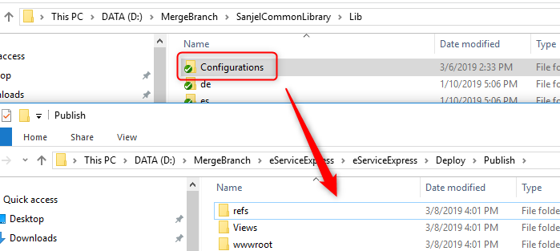

* 1. Update release build batch file

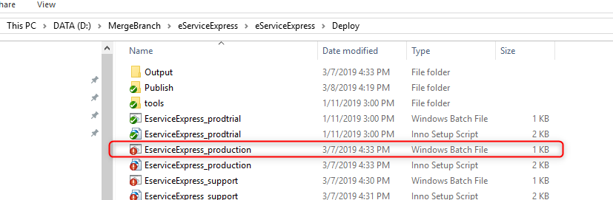

* 1. Update version number and save

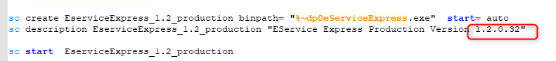

* 1. Open Inno Setup Script with Inno Setup and Compile. Inno Setup download link <http://www.jrsoftware.org/isinfo.php>

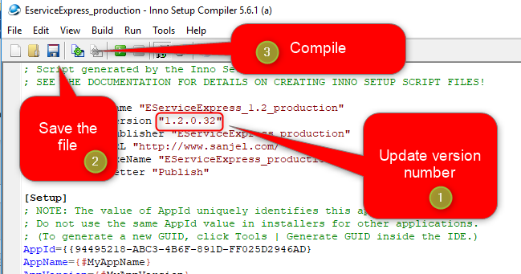

* 1. You may find the installation file in Output folder

